Abingdon Elementary School
4th and 5th Grade Band and Strings Program
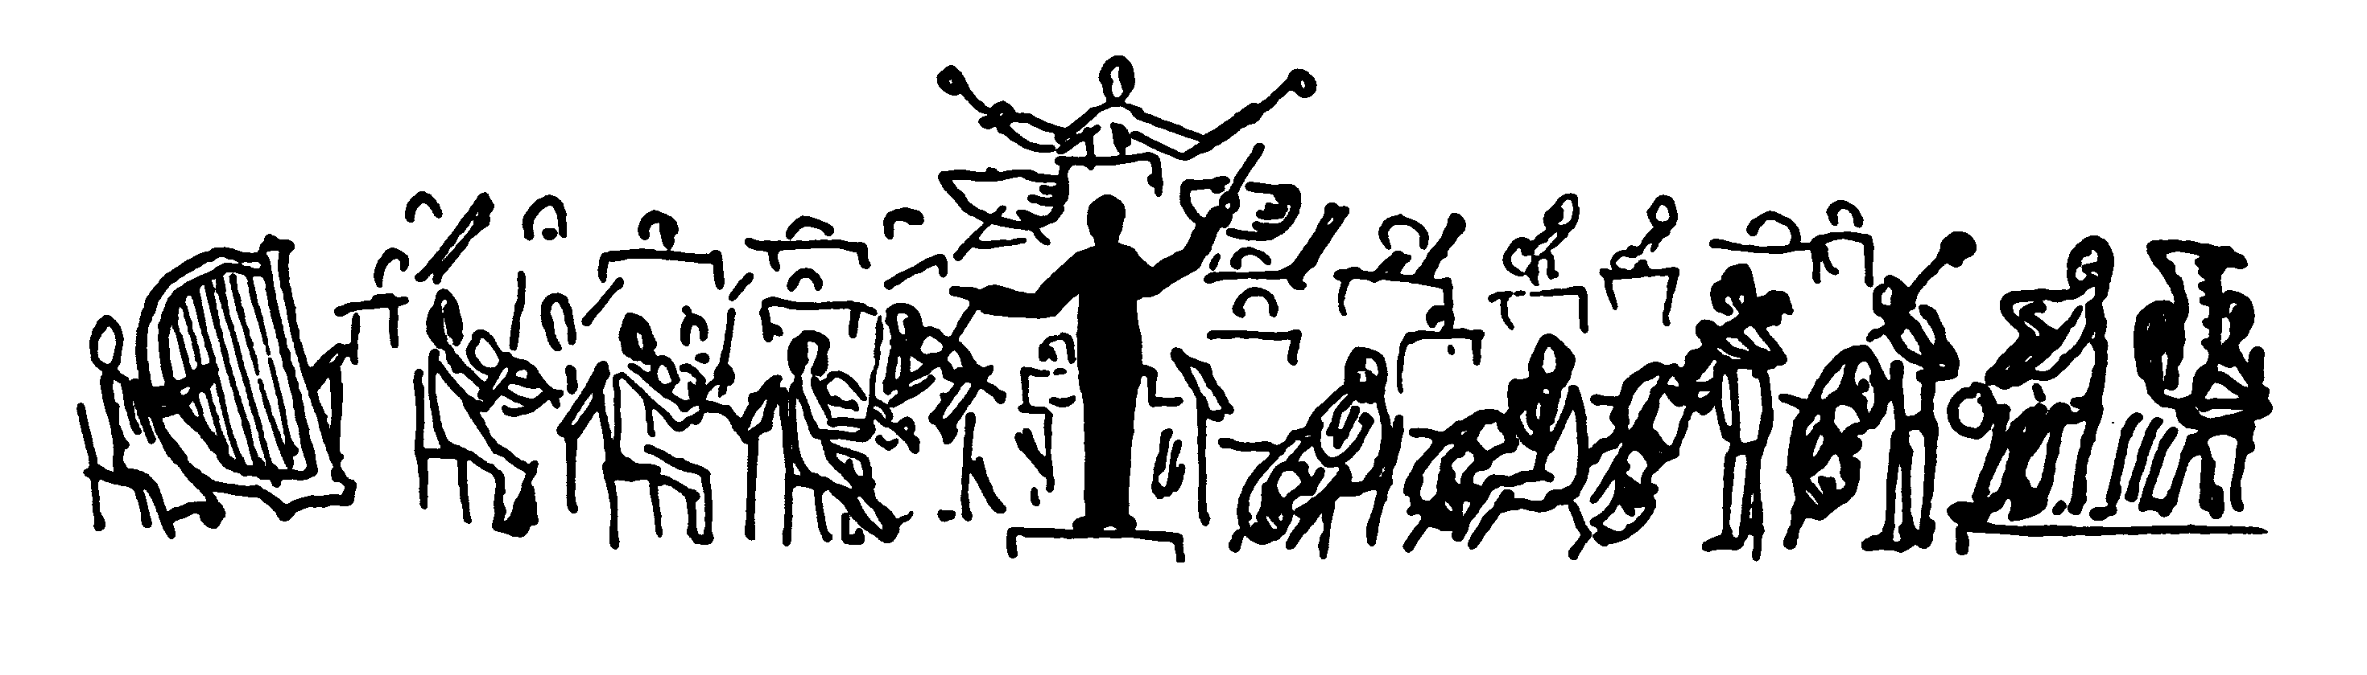
Welcome to Band and Strings at Abingdon

All 4th and 5th grade students at Abingdon will be part of our Band or Orchestra Program.

String Instruments include violin, viola, cello and bass.

Band Instruments include flute, clarinet, trumpet, trombone, baritone and saxophone.

Your child has chosen to take Strings!

Instrument: _________________________________________________________

Please do not buy an instrument for your child without first consulting a music teacher.

We have class once every 6th day. A calendar is posted on the Violin Page of the Abingdon website. Look Under the project GIFT tab and then click on Violin.

Some before-school lessons and rehearsals may be organized during the year.

We are planning on our final concert on June 7 at 7pm.

Kristin Gomez, Strings Teacher
Kristin.Gomez@APSVA.US

